LEAVE EMPTY | Abstract title for the EuroMOF2021 conference (Cambria 12 pt, bold, aligned left, select ‘MOF 2’ style from the Styles menu)  one empty line  Name Surname-Presenting Author Underlined*, Name Surname*, Name Surname**, Name Surname**, Name Surname***, Name Surname** (Cambria, 11 pt, aligned left, select ‘MOF 3’ style from the Styles menu), each affiliation should be indicated by different number of asterisks.  one empty line  *Institution One, Country One, e-mail address of presenting author, **Institution Two, Country Two, ***Institution Three, Country Three. (Cambria, 10 pt, aligned left, select ‘MOF 4’ style from the Styles menu).
one empty line
Main text (Cambria, 10 pt, justified). Abstracts should be submitted as .doc or .docx files ONLY prepared using this template (downloaded from the conference website). Please do not change text format, margins, line spacings, etc. Abstract length must not exceed 1 page. As the author of the submitted work, it is your responsibility to ensure that the abstract is prepared correctly and according to the format given in the abstract template. The abstracts will be printed as received.

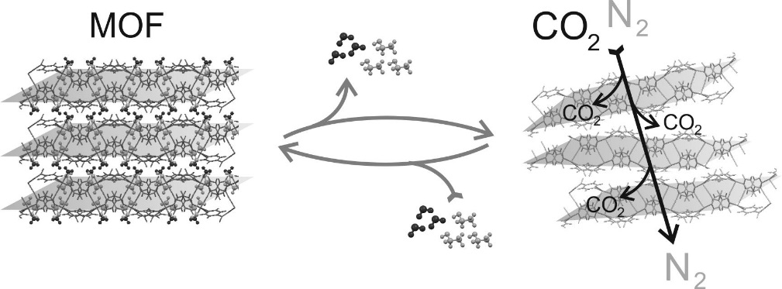

Figure 1. Figure caption – optional (Cambria, 9 pt, centered).
one empty line
Figures (optional) are accepted in grayscale, resolution 300 dpi. Please note that the conversion of colored figures into grayscale may result in loss of important information. References should be indicated in brackets [1-3].
The abstract file should be saved as SX_Surname_Name.docx or SX_Surname_Name.doc in which SX is a section code selected from the list given in the conference website (S1-S9), e.g.: S3_Smith_John.docx.
one empty line
References and acknowledgements – optional (Cambria, 10 pt, italic, aligned left).
[1] N. Copernicus, Chem. Eur. J. 81 (2020) 1049; [2] A.L. Smith, J.J. Brown, Inorg. Chem. 11 (1999) 87; [3] K. Olszewski, US Patent No. 8 411 639 B2, 2003. (References: Cambria, 10 pt, aligned left).

